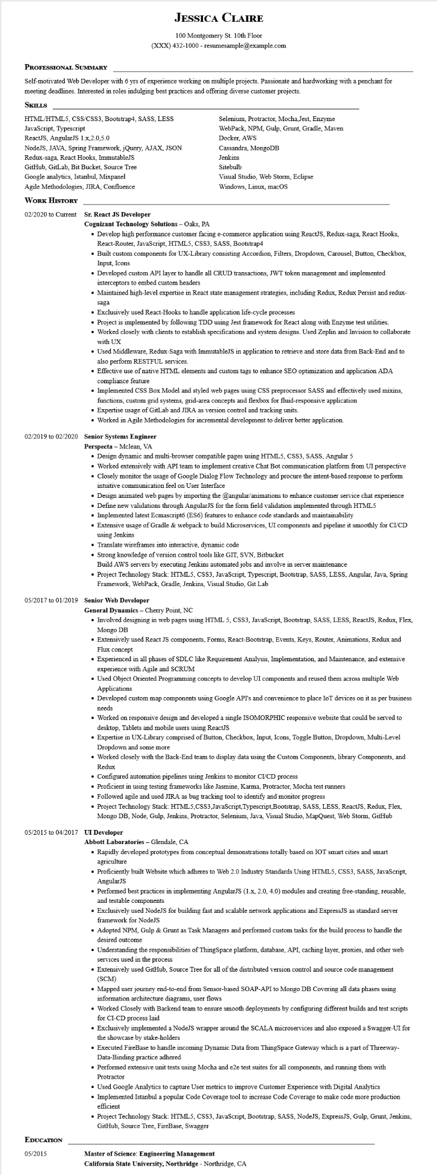
JESSICA CLAIRE
100 Montgomery St. 10th Floor (XXX) 432-1000 - resumesample@example.com
PROFESSIONAL SUMMARY
Self-motivated Web Developer with 6 yrs of experience working on multiple projects. Passionate and hardworking with a penchant for meeting deadlines. Interested in roles indulging best practices and offering diverse customer projects.
SKILLS
HTML/HTML5, CSS/CSS3, Bootstrap4, SASS, LESS
JavaScript, Typescript
ReactJS, AngularJS 1.x,2.0,5.0
NodeJS, JAVA, Spring Framework, jQuery, AJAX, JSON
Redux-saga, React Hooks, ImmutableJS
GitHub, GitLab, Bit Bucket, Source Tree
Selenium, Protractor, Mocha, Jest, Enzyme
WebPack, NPM, Gulp, Grunt, Gradle, Maven
Docker, AWS
Cassandra, MongoDB
Jenkins
Sitebulb
Google analytics, Istanbul, Mixpanel
Agile Methodologies, JIRA, Confluence
Visual Studio, Web Storm, Eclipse
Windows, Linux, macOS
WORK HISTORY
02/2020 to Current Sr. React JS Developer
Cognizant Technology Solutions - Oaks, PA
• Develop high performance customer facing e-commerce application using ReactJS, Redux-saga, React Hooks, React-Router, JavaScript, HTML5, CSS3, SASS, Bootstrap4
• Built custom components for UX-Library consisting Accordion, Filters, Dropdown, Carousel, Button, Checkbox, Input, Icons
• Developed custom API layer to handle all CRUD transactions, JWT token management and implemented interceptors to embed custom headers
• Maintained high-level expertise in React state management strategies, including Redux, Redux Persist and redux- saga
• Exclusively used React-Hooks to handle application life-cycle processes
• Project is implemented by following TDD using Jest framework for React along with Enzyme test utilities.
• Worked closely with clients to establish specifications and system designs. Used Zeplin and Invision to collaborate with UX
• Used Middleware, Redux-Saga with ImmutableJS in application to retrieve and store data from Back-End and to also perform RESTFUL services.
• Effective use of native HTML elements and custom tags to enhance SEO optimization and application ADA compliance feature
• Implemented CSS Box Model and styled web pages using CSS preprocessor SASS and effectively used mixins, functions, custom grid systems, grid-area concepts and flexbox for fluid-responsive application
• Expertise usage of GitLab and JIRA as version control and tracking units.
• Worked in Agile Methodologies for incremental development to deliver better application.
02/2019 to 02/2020 Senior Systems Engineer
Perspecta - Mclean, VA
• Design dynamic and multi-browser compatible pages using HTML5, CSS3, SASS, Angular 5
• Worked extensively with API team to implement creative Chat Bot communication platform from UI perspective
• Closely monitor the usage of Google Dialog Flow Technology and procure the intent-based response to perform intuitive communication feel on User Interface
• Design animated web pages by importing the @angular/animations to enhance customer service chat experience
• Define new validations through AngularJS for the form field validation implemented through HTML5
• Implemented latest Ecmascript6 (ES6) features to enhance code standards and maintainability
• Extensive usage of Gradle & webpack to build Microservices, UI components and pipeline it smoothly for CI/CD using Jenkins
• Translate wireframes into interactive, dynamic code
• Strong knowledge of version control tools like GIT, SVN, Bitbucket
Build AWS servers by executing Jenkins automated jobs and involve in server maintenance
• Project Technology Stack: HTML5, CSS3, JavaScript, Typescript, Bootstrap, SASS, LESS, Angular, Java, Spring Framework, WebPack, Gradle, Jenkins, Visual Studio, Git Lab
05/2017 to 01/2019 Senior Web Developer
General Dynamics - Cherry Point, NC
• Involved designing in web pages using HTML 5, CSS3, JavaScript, Bootstrap, SASS, LESS, ReactJS, Redux, Flex, Mongo DB
• Extensively used React JS components, Forms, React-Bootstrap, Events, Keys, Router, Animations, Redux and Flux concept
• Experienced in all phases of SDLC like Requirement Analysis, Implementation, and Maintenance, and extensive experience with Agile and SCRUM
• Used Object Oriented Programming concepts to develop UI components and reused them across multiple Web Applications
• Developed custom map components using Google API's and convenience to place IoT devices on it as per business needs
• Worked on responsive design and developed a single ISOMORPHIC responsive website that could be served to desktop, Tablets and mobile users using ReactJS
• Expertise in UX-Library comprised of Button, Checkbox, Input, Icons, Toggle Button, Dropdown, Multi-Level Dropdown and some more
• Worked closely with the Back-End team to display data using the Custom Components, library Components, and Redux
• Configured automation pipelines using Jenkins to monitor CI/CD process
• Proficient in using testing frameworks like Jasmine, Karma, Protractor, Mocha test runners
• Followed agile and used JIRA as bug tracking tool to identify and monitor progress
• Project Technology Stack: HTML5, CSS3, JavaScript, Typescript,Bootstrap, SASS, LESS, ReactJS, Redux, Flex, Mongo DB, Node, Gulp, Jenkins, Protractor, Selenium, Java, Visual Studio, MapQuest, Web Storm, GitHub
05/2015 to 04/2017 UI Developer Abbott Laboratories - Glendale, CA
• Rapidly developed prototypes from conceptual demonstrations totally based on IOT smart cities and smart agriculture
• Proficiently built Website which adheres to Web 2.0 Industry Standards Using HTML5, CSS3, SASS, JavaScript, AngularJS
• Performed best practices in implementing AngularJS (1.x, 2.0, 4.0) modules and creating free-standing, reusable, and testable components
• Exclusively used NodeJS for building fast and scalable network applications and ExpressJS as standard server framework for NodeJS
• Adopted NPM, Gulp & Grunt as Task Managers and performed custom tasks for the build process to handle the desired outcome
• Understanding the responsibilities of ThingSpace platform, database, API, caching layer, proxies, and other web services used in the process
• Extensively used GitHub, Source Tree for all of the distributed version control and source code management (SCM)
• Mapped user journey end-to-end from Sensor-based SOAP-API to Mongo DB Covering all data phases using information architecture diagrams, user flows
• Worked closely with Backend team to ensure smooth deployments by configuring different builds and test scripts for CI-CD process laid
• Exclusively implemented a NodeJS wrapper around the SCALA microservices and also exposed a Swagger-UI for the showcase by stake-holders
• Executed FireBase to handle incoming Dynamic Data from ThingSpace Gateway which is a part of Threeway- Data-Binding practice adhered
• Performed extensive unit tests using Mocha and e2e test suites for all components, and running them with Protractor
• Used Google Analytics to capture User metrics to improve Customer Experience with Digital Analytics
• Implemented Istanbul a popular Code Coverage tool to increase Code Coverage to make code more production efficient
• Project Technology Stack: HTML5, CSS3, JavaScript, Bootstrap, SASS, NodeJS, ExpressJS, Gulp, Grunt, Jenkins, GitHub, Source Tree, FireBase, Swagger
EDUCATION
05/2015
Master of Science: Engineering Management
California State University, Northridge - Northridge, CA

